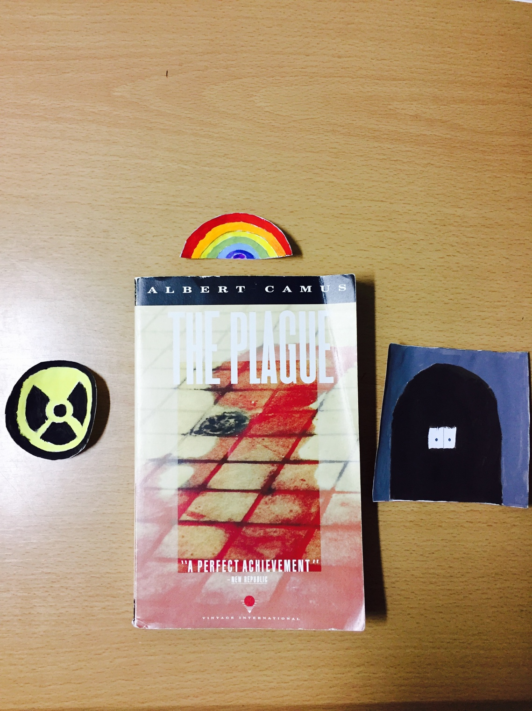

Tuan Nguyen

Book Bento for The Plague by Albert Camus

Hazard symbol

-The plague setting in a town of Oran. The town consists of unusual things, such as it has no pigeons, tree or garden. The life of people in the town is bored. They devoted themselves to cultivating habit. Like, they hang out in the cafes or playing bowling. They worked every day, except Saturday afternoon and Sunday, to earn as much as possible. Their life is going on normally until unusual even occur when Dr. Rieux realized that he has stepped on a dead rat. He thought it could be some youngster try to play a trick. Soon after he finds the strange death of his concierge, he believes that it could a disease. After the death of one citizen lead to another, the government decided to lock up the gate. From a peaceful town, before the coming of the dead rat, now it turns into the place of the suffering and isolating.

Rainbow

-The color of the rainbow present the personalities of different characters in the plague. Red is associated with passion and love. Dr. Rieux is helping to find a cure for the victim of the plague even he thinks it is impossible. Blue is associated with calm, knowledge, belief. Father Paneloux is knowledge and believes in order. He thinks the plague is a punishment for the townspeople. Orange is associated with exploring and creativity. Tarrou is a traveler, who just comes to the town to explore, but being lock up afterward. Violet is associated with mystery and imagination. Rambert who is a mysteries journalist that enter the town for an unknown reason.

Gate

The gate is present the separation of the townspeople from the outside world. Some of the townspeople are survived over the disease. Some other are tried to escape but died afterward. Townspeople are felt lonely and isolates from their relatives. The tragic death of the innocent is a sadist heartbreak of others. People are bear witness to the death of their loved one. For instance, Camus says, “They had already seen children die for many months now death had shown no favoritism but they had never yet watched a child’s agony minute by minute” (p.214). The feeling of watching the death of innocent boy make them feel helpless.